Collaboration in the IEP Environment: Module 2
This course focuses on conflict prevention and resolution and is the second part of a curriculum developed by Nicholas Martin on collaboration in the IEP environment. Many situations that involve conflict might be better handle if we understand the ‘emotional side of living.’ There are five main points that as individuals we need to be aware while dealing with an event. They are: the event, the mental response, feelings, behaviors, and the consequences. Often times, an event don’t shape our feelings, but our thinking does; thinking always lead to feelings. Feelings in turn are expressed in some form of behavior. These behaviors always have consequences for self, for others, and for the situation.
Behaviors trains lead to actions that sometimes are positive and sometime negative. Behavior trains (or when people feel hurt) can be resolved by communicating effectively about the situation. Another feeling is anger and the four pillars that make up this feeling are fear, hurt, frustration, and injustice. So, in order to help people deal with anger, we need to figure out what people do while angry. Angry does not resolved by expressing it but it only resolves when the underlying feelings are also being expressed.
In section 22, the author talked about serenity which can be useful in the presence of stressful situation. The combination of relation and deep breathing can help a person keep calm. The author gave four different approaches to relaxation. One technique involves progressive muscle relaxation that leads to peace, serenity, and total relaxation. With these awareness of how to become relax comes the flexibility of making better choices.
It is good to have conversations with yourself, assessing the cons and the pros of a situation. Once you clarified what your philosophy and what is your highest vision and have the courage of follow it. Basically, always do the right thing and things will work out.
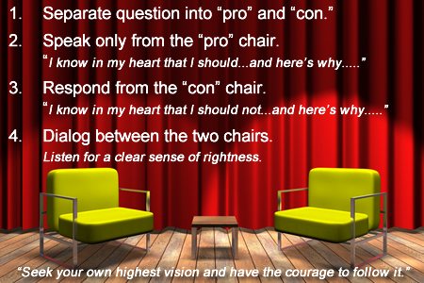
The five key points that will help lead to a resolution in conflict are summarized in this paragraph. Relax and breathe as awareness leads to better choices. Positive thinking promotes positive behaviors. Attitude is everything. Communicate effectively as many people can see the light differently but all will contribute to the light in the room. Trust the process because together we can accomplished great things.

