Project Improvement
By: Gloria Chen
EDSP 6315: Practicum in Diagnosis
May 8, 2014
Dr. Reed

Purpose of the Project
The purpose of this study is to examine how vocabulary development is associated with improving reading comprehension in ESL students in a bilingual program and ELLs in an ESL class where the instruction is mainly in English. Many aspects of the vocabulary development were considered during this study. The first aspect was to look at the I Station data at Cornelius and target strengths and weakness according to objective and subject. The finding from the I-station data indicated that I-station was not a valid source to assess the strengths and weakness of a reading and language arts. Thus, further research was conducted on what has been done to improve vocabulary in ELLs. Much of the body of literature found on ELLs and vocabulary development suggest the used of cognates, suffixes, prefixes, word analysis, and direct vocabulary instruction are associated with gains in reading comprehension and academic improvement in ELLs.
J. P. Cornelius Elementary is located in southeast Houston in district 3 of the Houston Independent School District. The school community is approximately 80% Hispanic, nineteen percent African American, 1% White, and less than 1% Asian/Pacific Islander. During this research, my focus was third grade bilingual and ESL groups. These groups set the tone on the achievement in later grades; the past years suggested that if the students do well in third grade; they have a good chance to do well in 4th and 5th grade. The 2013 Spring STAAR data reflects that 92% of the third grade students regular and bilingual met the state standard on the 2013 STAAR Reading Test. According to the TEA 2012 Indicator Report (Spring Administration), 67% of ELLs met the standard in grades 3rd through 5th. This is one content area where the school would like to improve student growth and achievement.

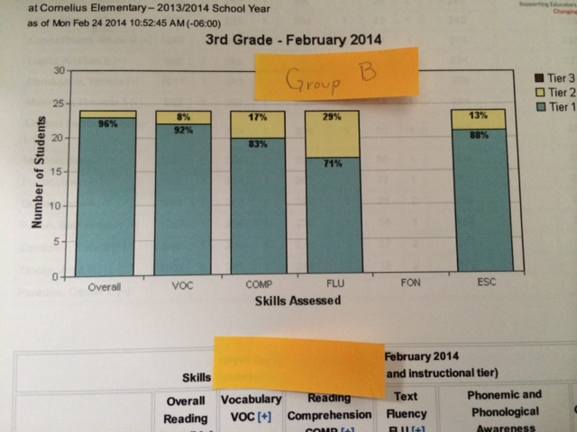
I-station is a federally funded program that delivers individualized instruction in the different domains of reading: phonemic awareness, alphabetic knowledge, vocabulary, comprehension and fluency. The purpose for using I-station data was to determine which groups of students struggled the most in reading and help teachers to make informed decisions to target those areas. Two groups were selected from third grade were selected randomly and the two groups were observed- group A and group B. I used a letter to identify the group in order to keep the confidentiality agreement established at the beginning of my internship. According to research (see literature review later in this report), vocabulary development and target strategies are associated with student’s gains in reading comprehension and achievement. Reports from I-station were run and used to compare the student progress in reading, find strengths and weakness, and also to compare the performance from both classes.
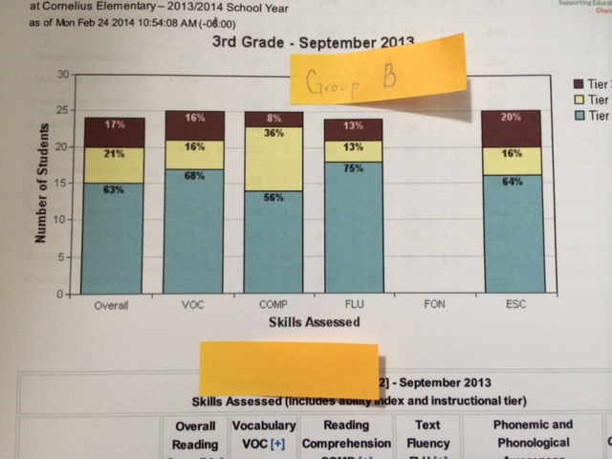

After taking a close look at the data, group B data showed significantly improvement from September to March. Group A showed improvements but group B showed a significant improvement in all areas. In Group B, 21 students were placed in Tier I and 3 students were placed in Tier II. By the end of February, there were no students placed in Tier III.
In Group A, 6 students were in Tier I, 13 in Tier II, and 8 in Tier III. See graphs below:
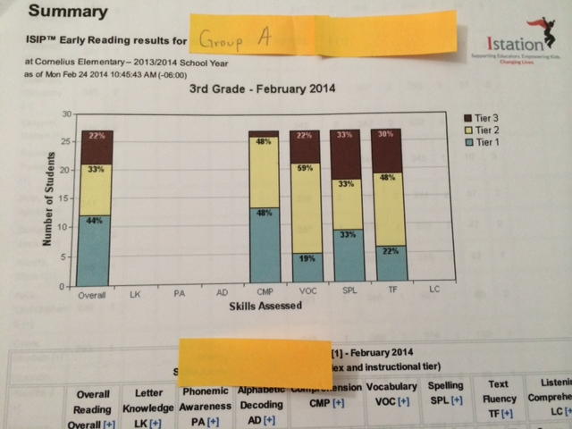
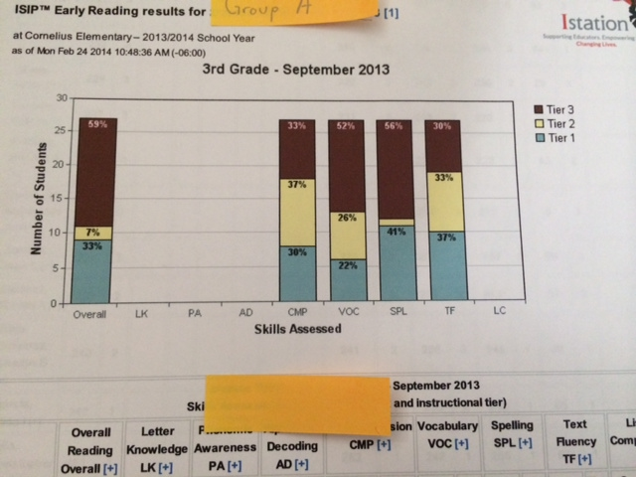

Although, the data showed that the students from Group B are doing better than the students from Group A; the reality was that during common assessments Group A showed more progress than all the other groups from the same grade level.
Other findings included that many children are not spending the time to read the prompt and keep clicking until they find the game section of the I-station program; this was evident in kindergarten where the time spent per question was about 1 second per question. My findings were supported by Teacher Development Specialist (TDS) Mr. Martinez who verified that HISD had similar findings earlier this school year. These findings indicated that the data from this program was not a good source by itself to assess the weakness and strength of ELLs or valid for making predictions/modifications in the instruction in order to improve the quality of the bilingual and ESL vocabulary instruction.
The finding from the I-station data indicated that I-station was not a valid source to assess student’s success in reading. Thus, further research was conducted on what has been done to improve vocabulary in ELLs. Much of the body of literature found on ELLs and vocabulary development suggest the used of cognates, suffixes, prefixes, word analysis, and direct vocabulary instruction. Researchers suggest that vocabulary strategies are associated with gains in reading comprehension and academic improvement in ELLs.
In order to meet the needs of ELL students, Cornelius Elementary serves this population by providing bilingual and ESL programs in order to assist them with language acquisition. The bilingual program follows the Late-Exit or Developmental model where students received instruction in their native language (Spanish) while at the same time receiving instruction in English. The goal is to develop the students’ vocabulary without losing sight of their academic progress. Bilingual teachers have received TELPAS training to assess the level of ELLs in English. Although, the goal is to help students transition to mainstream, English-only classrooms as quickly as possible, the transition is not always as smooth as teachers, administrators, students, and parents would like. The Developmental bilingual education program teaches core courses such as Reading, Math, Language, and history in the student’s native language, in this case Spanish. This bilingual education program spends only a small percentage of their time at school learning English. In pre-Kinder, and Kindergarten, the students received approximately 30-45 minutes. In first and second grade, the students received 60 minutes of ESL and 30 minutes in the content areas. In third grade, the students received 75 minutes of ESL and 45 minutes in the content areas. From Pre-K to third grade, the students are provided with a foundation in their native language while they learn a second language. In fourth grade, the students are transitioned to an ESL where the instruction is in English-only classrooms.

Literature Review
Who are LEP students? LEP stands for limited English Proficiency. According to the Federal definition provided by Rhodes, Ochoa, & Ortiz (2005), LEP students are those who struggle with speaking, reading, writing, or understanding English and ‘whose difficulties may deny access to learn meaningfully in mainstream environment where the primary language of instruction is English.’ This definition is somewhat problematic as it does not address the different levels of English proficiency as the range of proficiency may vary from beginner to high advance. According to Klingner, Artiles, and Barletta (2006), ‘ELLs tend to exhibit lower academic achievement in literacy than their non-ELL peers’ (p.108). At Cornelius Elementary, many ELLs struggled in reading in grades three through fifth grade. This problem is magnified in 4th and 5th grade where the instruction is in English only. Many of these children are at risk of being label learning disabled if they failed to meet the standard on standardized assessments such as STAAR. The general teachers in 4th and 5th grade have expressed their concerns and struggled to refer students to Special Education as they deal with the dilemma of not knowing if the struggle of an ELL lies on their proficiency with the language or with literacy in general or both.
According to researchers (Yildirim, Yildiz, & Ates, 2011) suggest that vocabulary development is a strong factor in predicting reading comprehension in expository texts. They suggest that student’s vocabulary is affected by his/her life’s experiences which in turn help them build prior knowledge they may use to improve comprehension in narrative texts. However for more complex text, vocabulary becomes a key predictor for comprehending expository texts (Yildirim, Yildiz, & Ates, 2011). These findings may benefit ELLs to overcome their struggles as they are expected to read all types of genres from narrative, historical fiction, to the more complex structure that include expository and scientific texts in the upper grades.
Kieffer & Box (2013) conducted a study for with Spanish speaking language minority (LM) learners and native English-speaking (NE) peers to investigate morphological awareness (MA) in reading comprehension. MA refers to students' meta-linguistic understanding of how complex words are formed from smaller units of meaning such as affixes, pre-fixes, roots, suffixes. Their research suggested that morphological awareness made unique contribution to reading comprehension. They stated that ‘facilitation of word reading by well-developed MA may translate into improved reading comprehension for both populations, whereas weaknesses in MA may be associated with word reading difficulties (Kieffer & Box, 2013, p. 169)’.
The goal of the project improvement is to determine whether vocabulary development contribute to reading comprehension gains in ELLs and ESL learners. Lervag & Aukrust (2010) examine the role of decoding and vocabulary skills as reliable predictors of reading comprehension in ELLs. Their research suggests that limitations in vocabulary development may hinder the developing comprehension skills in ELLs, and that oral development should be given a high priority in this group. This study aims to correlate the role of vocabulary development through strategies used with ELLs who transition into the mainstream with their reading gains in comprehension and student achievement which supports this project improvement for the bilingual students at Cornelius Elementary.
Findings
Currently, all of the HISD schools use I-station as a measure of student improvement in reading. However, this program is not a valid source of measurement of student reading progress and achievement. I-station data is not valid to make comparisons between groups of students in the same grade level. These findings were share with the principal and the assistant principal to share with the teachers at Cornelius during PLC meetings. They will not be using this data to monitor how well teachers and students are doing. However, they decided to keep using the I-station since the teachers like using the program with their students.
The findings of the body of literature suggested that there is a correlation between vocabulary development and reading comprehension for ELLs. Much of the research demonstrated the explicit instruction of vocabulary using a variety of strategies such as exposure to Morphological Awareness that involves the use of suffixes, prefixes, roots, as Kieffer & Box (2013) did by providing direct instruction of these strategies to native speakers and ELLs. Other findings (Lervag & Aukrust, 2010) indicate that oral development should be given a high priority in small group instruction for beginner learners, as well as the use of cognates.
Reflection
The current findings are extremely useful for any teacher who is using I-station as caution is advice if using I-station as a monitoring tool of reading and language arts performance. The findings of my research provided me with insight regarding the I-station software or any other software implemented in the classroom. The teacher must monitor the student progress and get to know the students as software might not paint an accurate picture of what the student really know. Also, the body of literature suggests that vocabulary development is correlated with gains in reading comprehension and achievement. Thus, more explicit vocabulary instruction is recommended especially for those students who are classified as beginner ESL students.

References
Lervag, A., & Aukrust, V. (2010). Vocabulary Knowledge Is a Critical Determinant of the Difference in Reading Comprehension Growth between First and Second Language Learners. Journal Of Child Psychology And Psychiatry, 51(5), 612-620.
http://libproxy.hbu.edu/login?url=http://search.ebscohost.com/login.aspx?direct=true&db=eric&AN=EJ1004379&site=eds-live&scope=site
Kieffer, M. J., & Box, C. (2013). Derivational Morphological Awareness, Academic Vocabulary, and Reading Comprehension in Linguistically Diverse Sixth Graders. Learning And Individual Differences, 24, 168-175. http://www.sciencedirect.com.libproxy.hbu.edu/science/article/pii/S1041608012001987
Klingner, J. (2006). English Language Learners Who Struggle With Reading: Language Acquisition or LD?. Journal Of Learning Disabilities, 39(2), 108.
http://eds.a.ebscohost.com.libproxy.hbu.edu/eds/detail?sid=3d342b30-8754-4dc5-8f90-34db857b4afd%40sessionmgr4003&vid=1&hid=4213&bdata=JnNpdGU9ZWRzLWxpdmUmc2NvcGU9c2l0ZQ%3d%3d
Rhodes, R. L., Ochoa, S. H., & Ortiz, S. O. (2005). Assessing Culturally and Linguistically Diverse Students. The Guilford Press, NY
Yildirim, K., Yildiz, M., & Ateş, S. (2011). Is Vocabulary a Strong Variable Predicting Reading Comprehension and Does the Prediction Degree of Vocabulary Vary according to Text Types. Educational Sciences: Theory & Practice, 11(3), 1541-1547.
http://libproxy.hbu.edu/login?url=http://search.ebscohost.com/login.aspx?direct=true&db=a9h&AN=82237447&site=eds-live&scope=site

